Compiler Design Lab-1

Mohit Kumar 23IT3028

Question-1:

FOR READING:
Code:
#include <bits/stdc++.h>
using namespace std;

int main()
{

// Open a file in read mode
ifstream file("test_file_for_lab.txt");
string s;

// Read string from the file
file >> s;

getline(file,s);
cout << "Read String: " << s;

return 0;
}

Output:
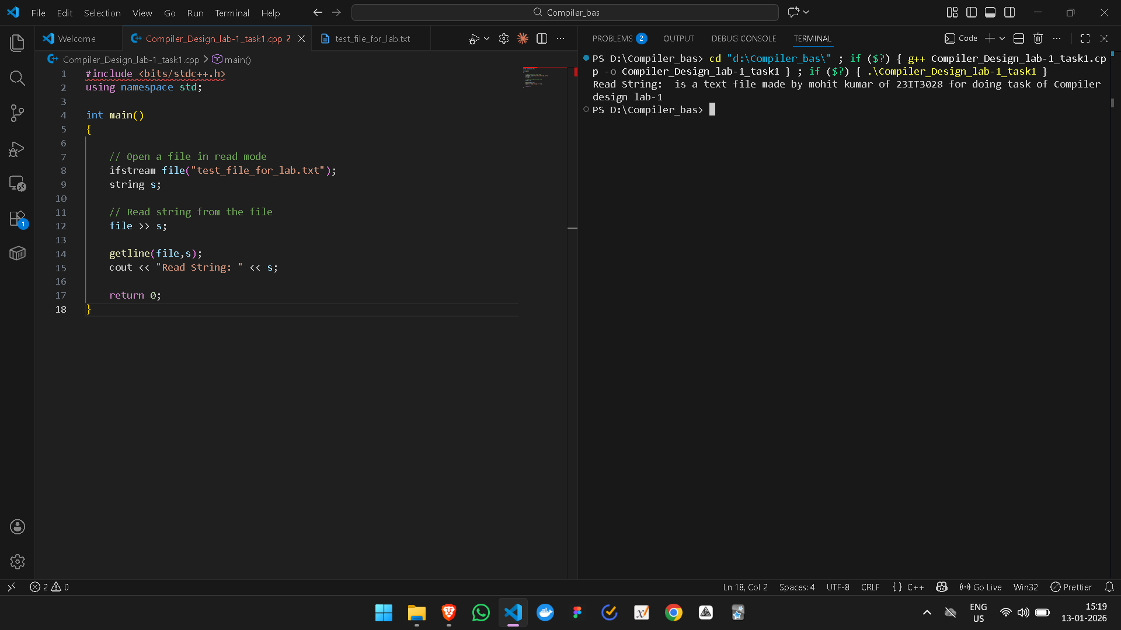

Part-2:
Writing in the file
Code:
#include <bits/stdc++.h>
using namespace std;

int main()
{

// Open a file in read mode
ifstream file("test_file_for_lab.txt");
string s;

// Read string from the file
file >> s;

getline(file,s);
cout << "Read String: " << s;

cout<<endl;
cout<<endl;

ofstream outputFile("test_file_for_lab");

outputFile << "Writing to file with ofstream! in my test file for part 2 of task-1"<<endl;
outputFile << "This is a second line added straight from VS Code "<<endl;

cout<<"This is the new test after giving input:";
cout << "Read String: " << s;

return 0;
}

Output:
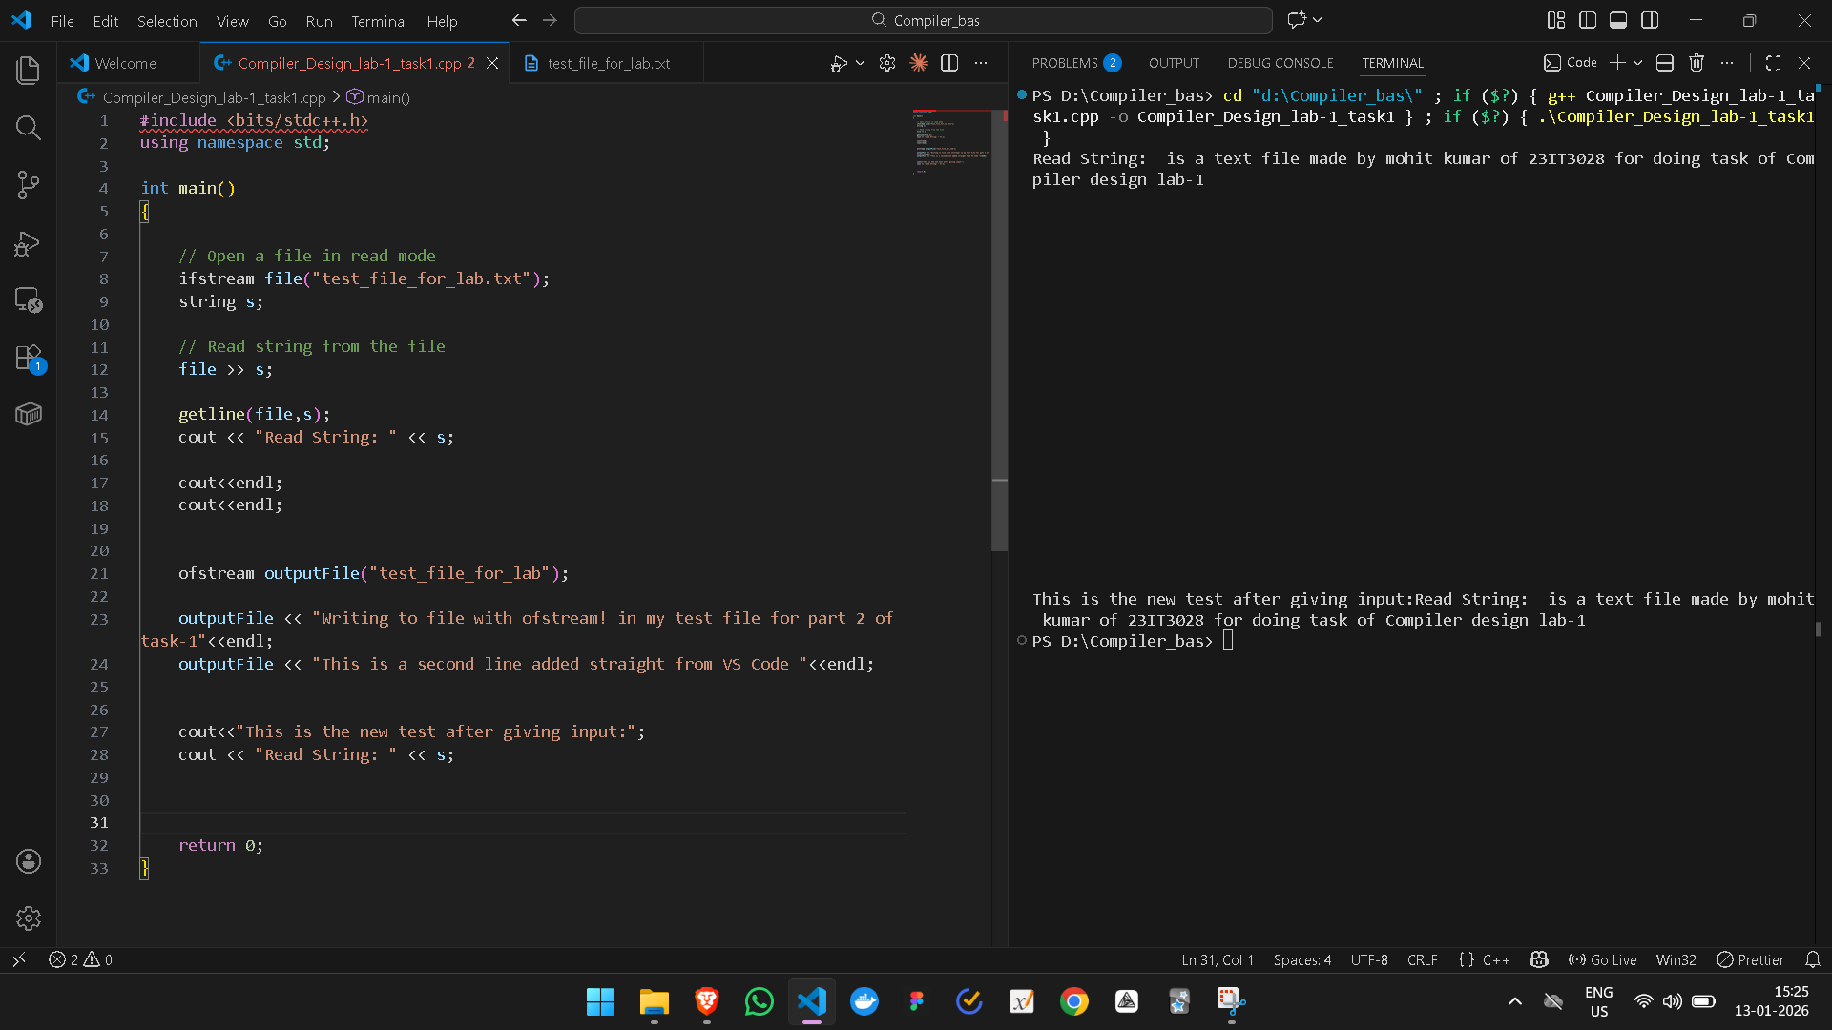

Question-2:
Code for counting:
#include<bits/stdc++.h>
using namespace std;

int main() {
// Specify the input filename
string filename = "test_file_for_lab.txt";
// Create an output file for demonstration purposes.
// If input.txt doesn't exist, this will create it with some sample data.
ofstream outFile("out_put_for_question_2");
if (outFile.is_open()) {
outFile << "This is line one.\n";
outFile << "This is line two, with a few more words.\n";
outFile << "Line three is here.";
outFile.close();
std::cout << "Created 'input.txt' with sample data.\n";
}

// Open the file for reading
std::ifstream inFile(filename);

if (!inFile.is_open()) {
std::cerr << "Error opening file: " << filename << std::endl;
return 1;
}

char character;
int charCount = 0;
int wordCount = 0;
int lineCount = 0;
bool inWord = false;
char prevChar = '\0';

// Read the file character by character
while (inFile.get(character)) {
charCount++;

// Check for new lines
if (character == '\n') {
lineCount++;
}

// Check for words (simple space, tab, or newline delimited)
if (character == ' ' || character == '\t' || character == '\n') {
if (inWord) {
wordCount++;
inWord = false;
}
} else {
inWord = true;
}

prevChar = character;
}

// If the file does not end with a space or newline, the last word needs to be counted
if (inWord) {
wordCount++;
}

// Increment line count if the file is not empty and the last character wasn't a newline
// This handles the case of the last line not having a terminating newline character.
if (charCount > 0 && prevChar != '\n') {
lineCount++;
}

// Close the file
inFile.close();

// Print the results
std::cout << "\nFile analysis for '" << filename << "':" << std::endl;
std::cout << "Characters: " << charCount << std::endl;
std::cout << "Words: " << wordCount << std::endl;
std::cout << "Lines: " << lineCount << std::endl;

return 0;
}

Output:
